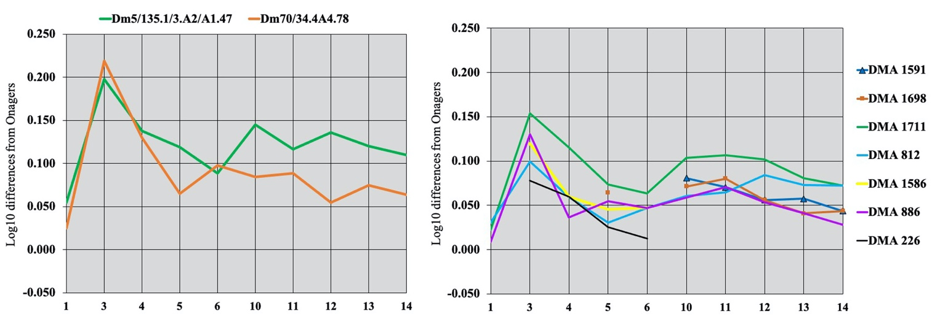

Figure S23. Simpson's diagrams of Dmanisi metatarsals from Layers IV-V, and Stratum A. 1:

Maximal length. 3: Breadth at the middle of the diaphysis. 4: Depth of the diaphysis at the same level. 5: Proximal breadth. 6: Proximal depth. 10: Distal supra-articular breadth. 11: Distal articular breadth. 12: Depth of the sagittal crest. 13: Least depth of the medial condyle. 14: Greatest depth of the medial condyle.